Fewer games, more boosts: how the World Cup concentrated the UK boost market
As the tournament narrowed to the knockout rounds, operators piled onto fewer fixtures with far more boosts on each. The headline generosity never moved. The value actually conceded quietly tightened. Jurnii 360 data tracks how the market reshaped itself around a shrinking fixture list.
Mitch Vidler · CCO · Jurnii
Across the 2026 World Cup, UK books ran more than six thousand World Cup price boosts. How those boosts were distributed, and how their value shifted, says a good deal about how operators compete when a tournament reaches its business end.

Volume builds to a late peak
Start with the raw count, because it sets up everything that follows. Boost volume climbed steadily through the tournament. In the build-up week the market was running around 30 World Cup boost detections a day. That rose to roughly 140 a day once the tournament kicked off, climbed again to about 216 through the opening group-stage week, and peaked near 283 a day in the closing group-stage week, when the final round of group fixtures was packed into a handful of days. It eased back to around 231 a day for the knockout rounds.
This trajectory tracks the fixture calendar. A boost is attached to a fixture, so the daily count rises as the schedule fills and the group stage stacks matches on top of one another. On its own, the volume line tells you how busy the calendar was, not how hard operators were competing.
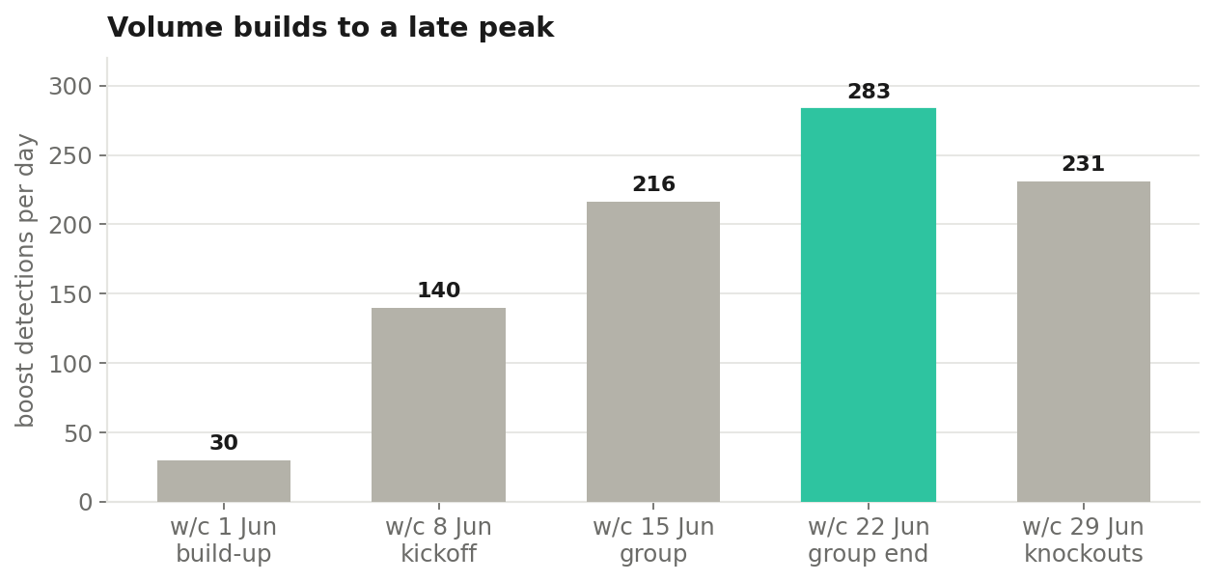
Boost volume tracks the fixture calendar, peaking when the final round of group matches is compressed into a few days.

The signal is per fixture
Normalise by the number of fixtures and the real pattern appears. Through the group stage the market boosted a wide field, 69 to 81 distinct World Cup fixtures a week, at around nine to seventeen boosts per fixture. As the tournament advanced the field collapsed, to 57 fixtures in the closing group-stage week and just 36 in the knockouts, but boosts per fixture went the other way, climbing to 28 and then to 36. Boosts per fixture in the knockouts ran at roughly four times the kickoff rate.
The interpretation is straightforward. As the tournament narrows, the market does not do less boosting. It does far more of it on far fewer games. Every book converges on the handful of fixtures left standing and competes harder on each one. The contest is not how many boosts a book runs, it is how many it stacks onto the fixtures that matter.
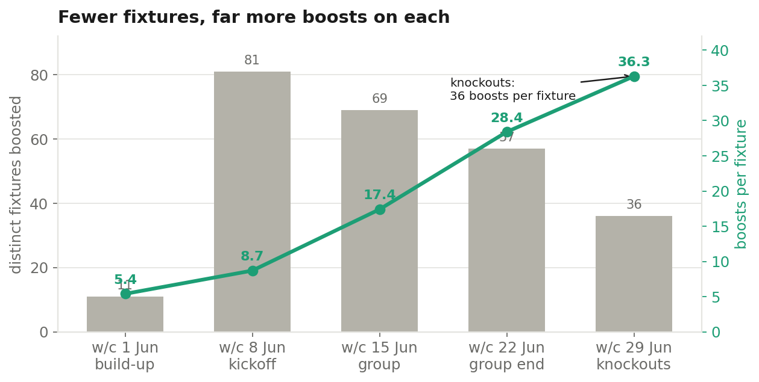
As the fixture list collapses into the knockouts, boosts per fixture climb relentlessly to their tournament high.

The headline held, the value tightened
Here is where the data corrects an easy assumption. You might expect that as operators pile more boosts onto the biggest games, they compete harder on price too. They did not. The headline boost held completely flat. The median World Cup boost sat at 20 per cent every single tournament week, from kickoff through the final, an anchor the market set early and never moved.
The value actually conceded tells a different story. Margin conceded, the true cost of a boost once the shortened price is accounted for, built to a peak in the opening group-stage week at around 2.8 percentage points, then fell away as the tournament climaxed, to about 2.4 points in the closing group stage and around 1.8 in the knockouts. So the shop window stayed fixed at 20 per cent while the real value behind it narrowed. Books kept the headline number constant and quietly conceded less on each boost as the games got bigger.
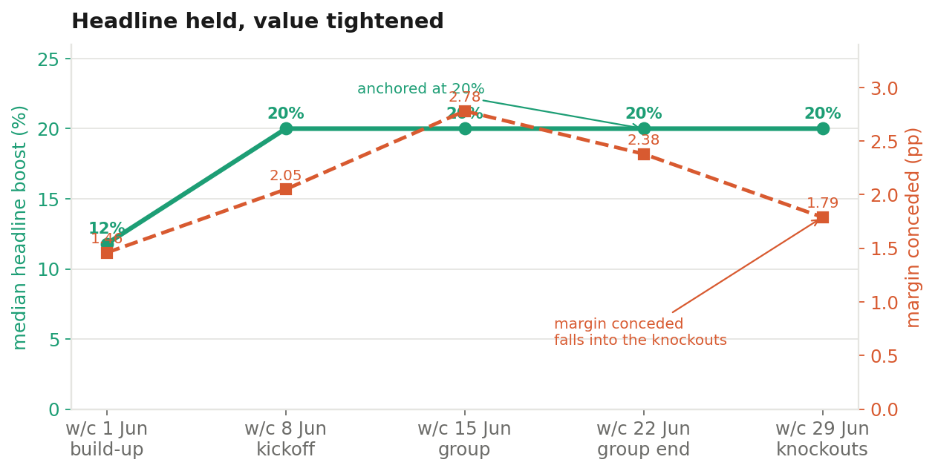
The headline boost is a fixed 20 per cent all tournament. The margin actually conceded peaks in the group stage and tightens into the knockouts.
Put the two together and the knockout picture is clear. More boosts per fixture, a headline number that never wavers, and slightly less true value behind each one. The market got louder on the big games and a little tighter on price at the same time.

Breadth is shared, depth is not
Underneath the average, the books do not split on how many fixtures they cover. They split on how deep they go. A lead group of Betfred, William Hill, Ladbrokes and Coral each boosted close to a hundred fixtures at eight to nine boosts per fixture, going both wide and deep. A second tier of BetVictor, Unibet and Betway covered a similar spread of fixtures, around 90 each, but at only two to three boosts apiece.
So coverage is table stakes. Almost everyone turns up on almost every fixture. The differentiation is depth, how many boosts a book is willing to stack on a game, and it is the lead group that commits. The thin books are present everywhere and prominent nowhere.

Where everyone converges
The clearest expression of that crowding is the fixture leaderboard. The most heavily boosted single games drew close to the entire market. Canada v South Africa attracted 121 boosts across twelve books, England v Mexico 112 across thirteen, Brazil v Norway 106 across eleven. When a match caught the market's attention, effectively every book boosted it, and boosted it heavily.
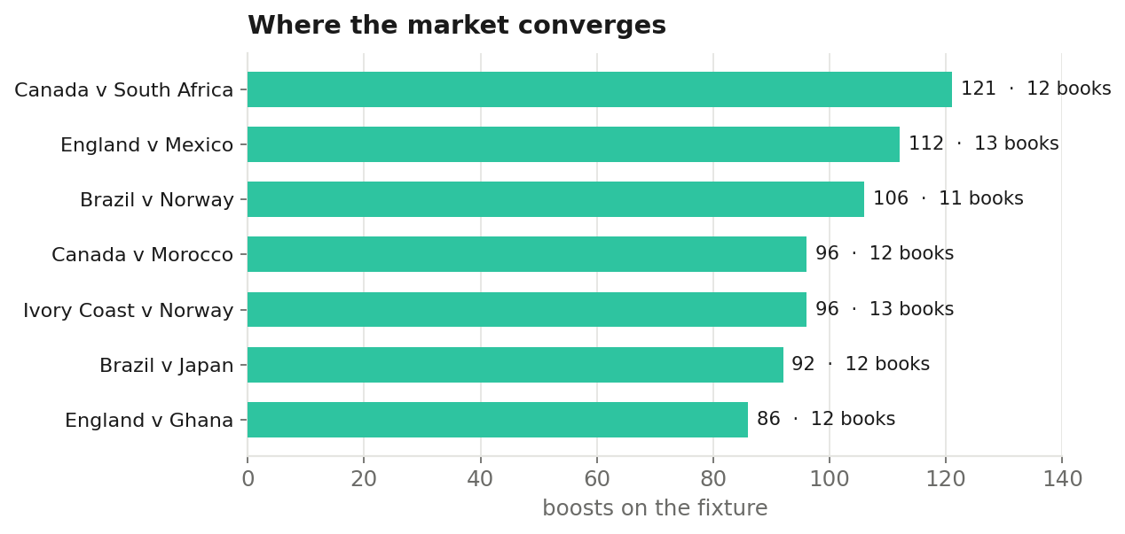
The most boosted fixtures drew close to the whole market, twelve or thirteen books deep on the same games.
That is the paradox the tournament sets for operators. The moments of peak attention are also the moments of least distinctiveness, because every trading floor reaches the same conclusion about which game to load up. The books that stood out did so not by picking different fixtures, but by going deeper on the obvious ones.

What it means
A narrowing tournament does not cool the boost market, it concentrates it. Operators held their headline generosity fixed, competed on depth rather than price, and crowded onto a shrinking set of fixtures with ever more boosts on each. For anyone competing through the closing rounds, the lesson is that the fight is per fixture, and it is fought on volume and prominence rather than on a bigger number. Turning up on the big games is expected. Standing out means stacking more onto the fixtures the whole market has already agreed are the ones that matter.

